13.26: In the example, 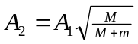 and now we want 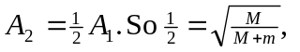or
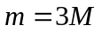. For the energy, 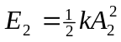, but since 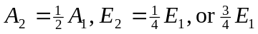 is lost to heat.

